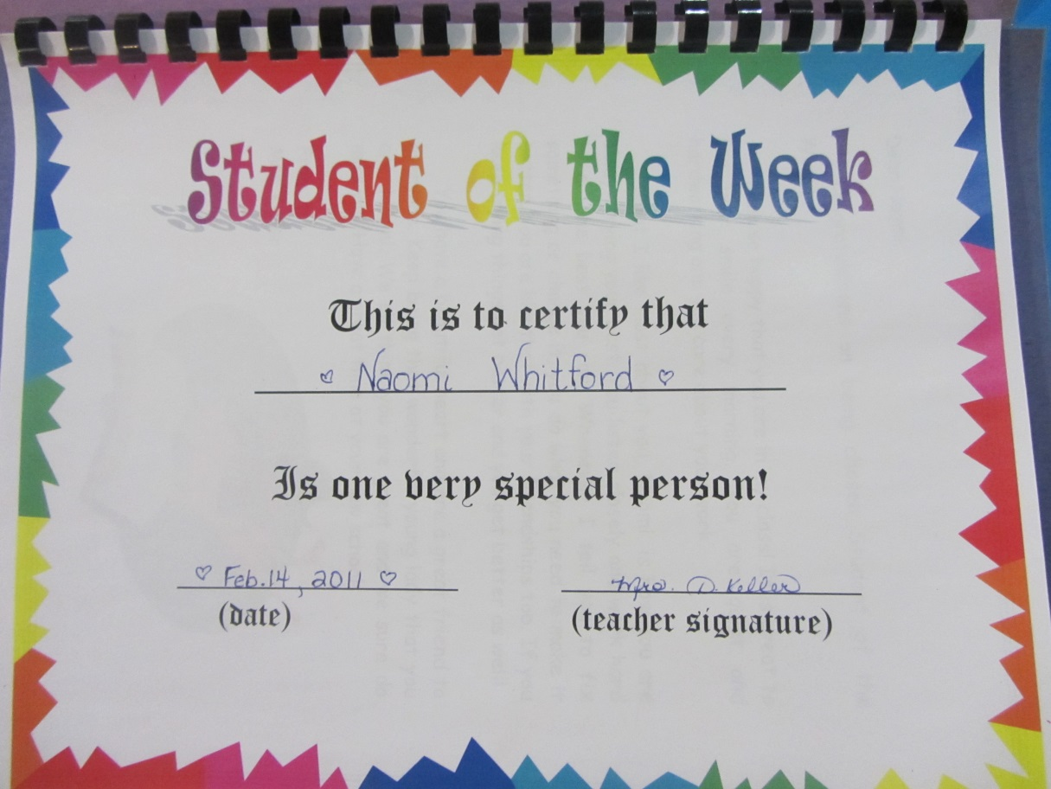
Student of the Week Project
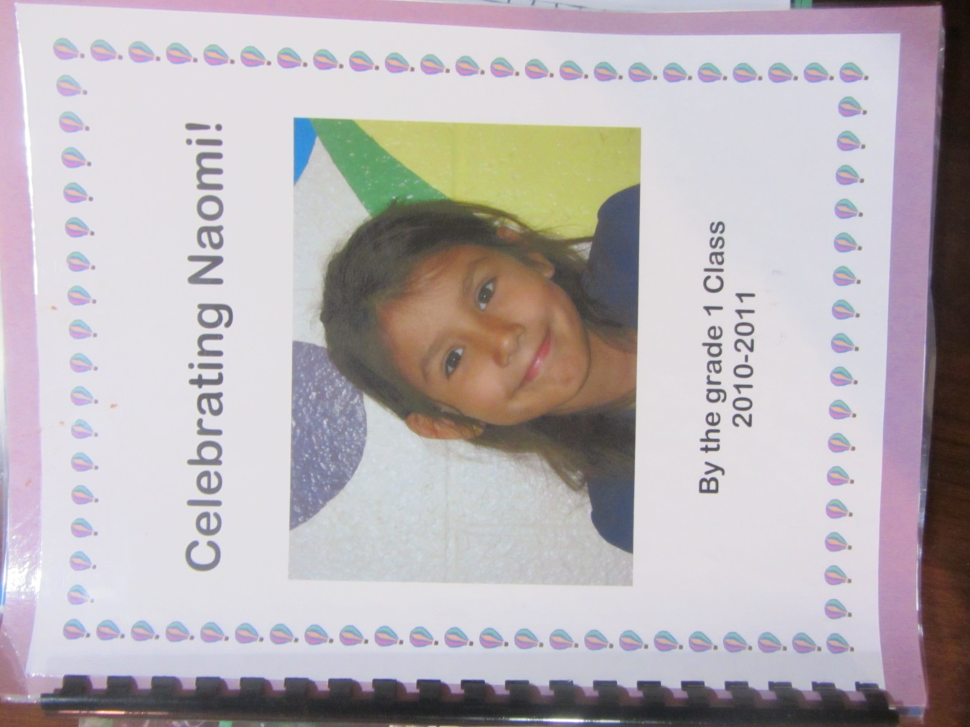

Pictures were taken with permission from student take home book: Student of the Week Project; Grade 1

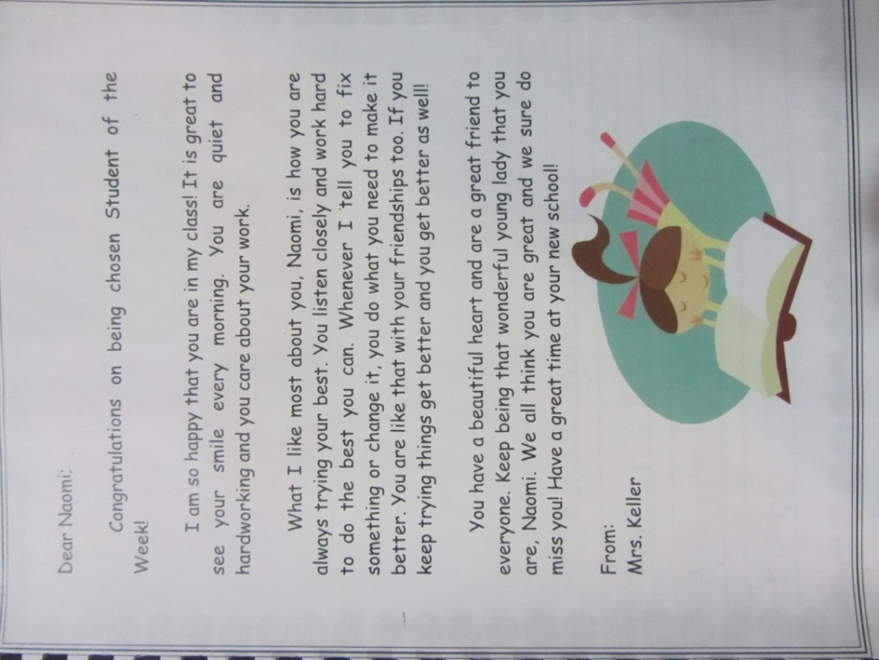
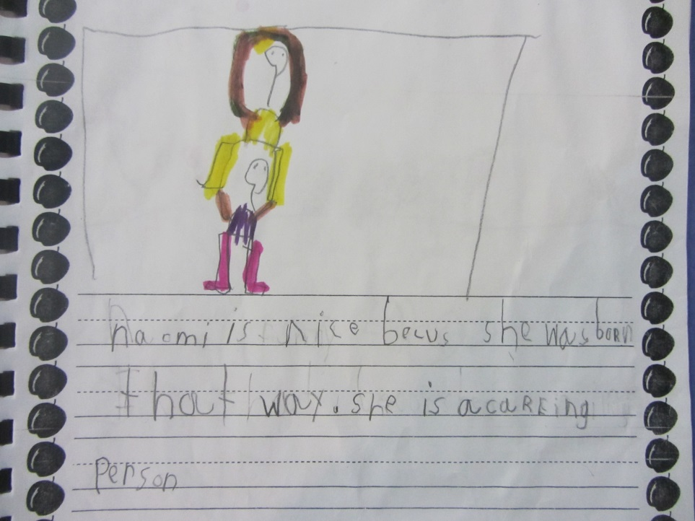
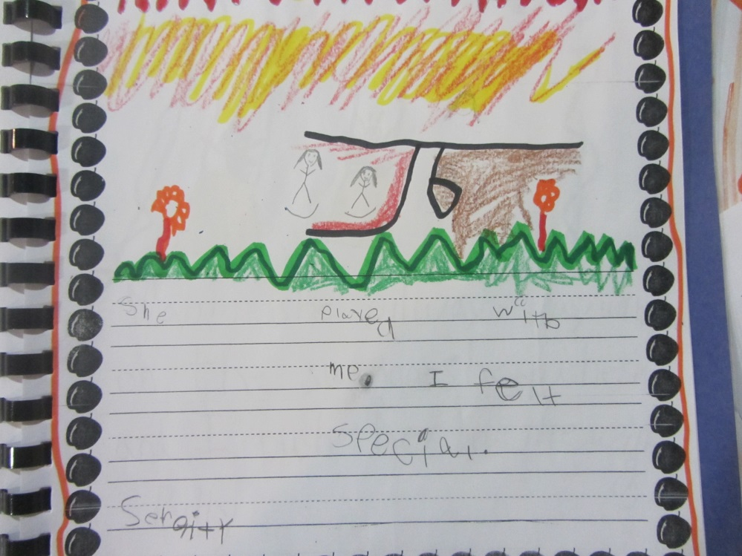

Deidre Keller deidre.keller@aspenview.org
Unit Plan: Best Class Ever! (Relationship Choices)
Outcomes:
*identify the characteristics of being a good friend
*examine how personal behavior and attitudes can influence the feelings and actions of others
*demonstrate simple ways to resolve conflict with limited adult assistance
*work cooperatively with a partner
*recognize and accept individual differences within a group

Lesson 1: Introduction: Present Problem, Brainstorm solutions, Create Pledge
Description:
Introduce the problem and have students generate ways to improve relationships within our class. Have them envision the Best Class Ever and work with the idea of building on what is working. Create a promise together to one another to do better and include one another. Introduction letter home.
Lesson 2: We belong together/ Differences Make Us Special
Description:
Show class photo. Discuss how we know we are a group, how we belong together. Talk about what makes us special. Imagine the best friend you have here, the best work partner what types of talents they show that makes them a good partner. Brainstorm a list of talents that we can all work on over the next few weeks.
Lesson 3: Building Our Talents - #1: Kindness
Read story, Mufaro’s Beautiful Daughters. Define kindness. Show people and stories that have been examples of kindness in our world. Create Kindness bulletin Board (Can We do 100 Acts of kindness before 100 day) Assessment: Introduce “Signs For Success” (checklist for each virtue – The Virtues Project, 1991) Ongoing reinforcement of virtue and letter home.
Lesson 4: #2 – Respect
Respect Popcorn PartyReinforce Respect by celebrating examples of it in the classroom. (lesson from: Education World: http://www.educationworld.com/a_lesson/04/lp329-01.shtml) Signs For Success” (checklist for each virtue – The Virtues Project, 1991) Ongoing reinforcement of virtue and letter home.

Lesson 5: #3 – Caring
Read the Rainbow Fish. Emphasize the Caring that took place and how important it is to include someone when you are caring. Students will create a Fish shaped caring book with examples of times when they were caring and including. Show examples of people who have been caring. Signs For Success” (checklist for each virtue – The Virtues Project, 1991) Ongoing reinforcement of virtue and letter home.
Lesson 6: #4 – Friendliness
Read story “Do You Want to Be My Friend” – Eric Carle. Definefriendliness, give examples. Show examples of people who have shown Friendliness.Have students role play times when they were friendly or could be friendly. Signs For Success” (checklist for each virtue – The Virtues Project, 1991) Ongoing reinforcement of virtue and letter home.

Lesson 7: #5 – Consideration
Four Feet Two Sandals by K. Williams (video https://www.youtube.com/watch?v=qGwRkPX8ETY) Create Friendly Cards for someone they know is in need. Field Trip to Wildrose Villa to visit Seniors. Signs For Success” (checklist for each virtue – The Virtues Project, 1991) Ongoing reinforcement of virtue and letter home.

Lesson 8: #6 – Self-Control
Description:
Show video of Donald Duck losing his self-control. Play Self-Control song. Define and give examples of self-control and people we know who have shown good self-control.Who Made You Move game: students show self-control and only move their specific body parts when they hear the sound of the drum. Ask in the end Who Made You Move? Transfer knowledge to other parts of their day and who made you do different things. Signs For Success” (checklist for each virtue – The Virtues Project, 1991) Ongoing reinforcement of virtue and letter home.
Lesson 9: #7 – Honesty
Description:
Watch Pinocchio Video. Define Honesty, give examples. Show stories and people who have been honest. Do object lesson: building a Relationship on honesty.

I used this object lesson when talking about lying with friends. I explained how you build up a relationship with a friend. And if you start lying to them then your relationship will crumble. I had a child pull a cup out from the "foundation" of the friendship. We talked about how it's a lot harder to build a relationship back up after you have been dishonest with them.
(From Pinterest)
Colour Poster: Honesty is the Best Policy. Signs For Success” (checklist for each virtue – The Virtues Project, 1991) Ongoing reinforcement of virtue and letter home.

Lesson 10: #8- Forgiveness
Define forgiveness and why it’s important. Read Under the Lemon Moon (going beyond forgiveness and doing an act of service for that person) Role-play what forgiveness looks like. Do Broken Heart craft (Draw heart and cut into 5-7 pieces and have them fit it back together, try to fit someone else’s heart back together.) Homework: Have them write down someone they will forgive in the next week and share about it in class or privately with me. Display pictures and stories of people who have been honest.Signs For Success” (checklist for each virtue – The Virtues Project, 1991) Ongoing reinforcement of virtue and letter home.

Lesson 11: Setting Goals to be our Best Selves
Description:
Culminating Activity – Show them the “My Best Me” goal sheet they will be doing with their parents to be their best selves. Popcorn Party. Certificate of Achievement on becoming the Best Class Ever.

Dear Parents/Guardians;
A focus in health in Grade 1 is Relationships.
With our class this year I presented a problem I had to the group and that I needed help solving it. I said that although I care about every member of this group and every single one is very special to me, I notice that we don’t always treat each other like we’re special and important. When that happens it is hard for me to teach because I want to help everyone get along and it doesn’t always happen. How can I solve this problem?
Of course they all said we should be nicer and kinder, so I took it a step further. I asked them to close their eyes and imagine if we were all “nice and kind” like they said. Imagine the nicest classroom in the world – what would that look like? What would the kids be doing? How would they act? How would they feel? What would the teacher be doing?
Here is what your children came up with (Beautiful!):
- Being nicer
- Being kinder
- Playing with each other
- Letting everyone in the game
- Helping each other when they get hurt
- Helping each other when they need help like when they spill their water, or they need help building a snow fort
- When we have a problem with someone we should talk it out
- We should listen to each other
- It doesn’t matter if we’re different
- Make new people feel like…you know…like – at home
- Wait your turn
- Don’t care if someone beats you at something, just say “Good Job”
From these ideas I have created a unit where we will learn about the skills they believe are important to have to become the “Best Class Ever” . We’ll focus on one skill at a time, what is it, how do we show it and practice, practice, practice it.
I will be sending notes home throughout the Unit to let you know which skill we are working on at the time and about our progress.
Stay tuned!
Sincerely yours

